Apollo v4 box

Contents

Overview 1

Main requirements 2

User experience (UX) 2

Reliability features 2

Connectivity options (optional) 2

Architecture 3

Controller board 3

Valve driver board 3

Sensor board 3

PCB design requirements 3

Individual components 4

Power 4

Valves 4

Solenoid control 4

Main controller 5

Display touchscreen 5

O2 sensor (flow/concentration) 5

Pressure sensors 5

Buzzer 5

Fuse 6

Buttons/switches 6

Terminals 6

Appendix 1 – DRV8806 6

# Overview

The Apollo v4 box is a modular system able to act as a control box for a variety of oxygen concentrator systems. It is tailored specifically for open source PSA oxygen concentrator variants.

The Apollo v4 electrical system consists in three or more boards stacked together:

1. **Top**: A control board. This contains the main microcontroller board (wireless version of Arduino or ESP32), a ~ 3” touch screen and an optional buzzer.
2. **Middle:** A valve driver board. The reference implementation will be able to drive eight valves at 12 or 24V and max 1A of current.
3. **Bottom:** A sensor board. This board will accommodate multiple sensor configurations needed for the functionality of the O2 concentrator.

We will offer reference implementations for all boards in the system. However, the system is modular in the sense that one can swap out various components as needed in order to create a better suited system for your oxygen concentrator. For instance, one can swap out the controller board from Arduino Nano 33 IoT to an ESP PICO KIT board. Or can swap the valve driver board with a different one able to work with different voltage or current ranges or with a lower cost.

# Main requirements

## User experience (UX)

* Will serve as main controller board for a variety of small/medium PSA systems
* Failure detection and display of actionable messages in the touchscreen
* Diagnostics messages displayed on a TFT LCD
  + Localizable in any language
  + Can display urgent maintenance instructions
* Buzzer with a snooze button

## Reliability features

* Fault detection
  + valve opens/shorts
  + alarms for O2 concentration
    - spent zeolite?
    - Valve mechanical failures?
  + Alarms for O2 flow drop
    - Leaks/clogs in the system?
    - Compressor failure?
    - Mechanical/pneumatic failures
  + Electrical power temporary failure

## Connectivity options (optional)

* + Cloud connectivity
    - The board will be able to connect to Azure or AWS web services through WiFi. The initial setup (SSID and subscription key provisioning) can be done automatically or manually though the touch screen.
  + Bluetooth connectivity
    - The controller board can connect to a smartphone or tablet via Bluetooth/BLE in order to supply
      * **Patient data** such as the PEEP pressure telemetry, breathing pattern, SpO2 data, etc.
      * **Delivered oxygen data** such as delivered O2 concentration, flow, pressure, temperature and humidity
      * **Device health data** such as parameters of the oxygen concentrator: compressed air pressure, PSA timing data/history, dryness of the incoming air, zeolite lifetime, etc.

# Architecture

<TBD – insert diagram>

## Controller board

The controller board will come in two versions.

* One version will be able to use Arduino Nano 33 IoT board. This board has support for WiFi and Bluetooth/BLE and has solid security features for cloud connectivity such as secure key storage. Second, this board has a main microcontroller chip (Microchip SAMD21 based on an ARM Cortex-M0+) which is different than the ESP32 microcontroller cores used for the wireless stack. Finally, this board has an attractive form factor – it is only 18 mm tall and has a 3D antenna.
* As an additional version, another version of the Apollo v4 control board will use the less expensive ESP32 PICO KIT variant. While slightly larger than the Arduino Nano 33 IoT and lacking security features and an extra core, it will be also 2x cheaper.

Both boards will accommodate inexpensive TFT touchscreens that fit into the standard Arduino Uno shield pinout format.

## Valve driver board

The valve driver board will accept DC input power and will be able to drive up to eight DC valves at either 12V or 24V. The valve board will offer fault detection such as opens or shorts. For instance, if a solenoid is burned or if a wire comes off due to vibration the system will detect this fault condition.

The same valve board will also contain the power delivery subsystem, able to convert the input voltage (12 or 24V) into a number of power busses needed for the various components.

## Sensor board

This board will offer on-board or off-board pressure sensors for the incoming compressed air or the outgoing O2. Also, the board will accommodate an oxygen concentration/flow sensor. Finally, one will be able to also hook up various temperature and/or humidity sensors.

# PCB design requirements

* Layout: 88mm x 88 mm = 7,744 sq.mm
  + Fits into Autodesk Eagle Freeware limitations so it can be edited with the free version of Autodesk Eagle
* Four standoff screws on each corner for increased mechanical stability
* PC104 bus connector (4x26 rows of standard 0.1” headers)
  + Bottom 2x26 rows used for Apollo v4 pin assignment. Please check the separate [Apollo_V4_Pins.docx](https://github.com/oxycon/ProjectApollo/blob/master/prototypes/Apollo%20v4%20(in%20progress)/docs/Apollo_V4_Pins.docx) document for pin assignment
  + Top 2x26 pins are reserved for future use.
* 2 layer PCB preferably (signal lines a ground plane)
  + (4 layer could be OK if ground plane hard to achieve)
* Eagle
* SMD preferred, pick&place will be done in a PCB manufacturer (Jlcpcb, pcbway, allpcb, etc)
* Multiple PCBs that can be stacked in a modular (Cubesat-like)fashion.
* The proposal is to have three boards:
  + Control board
    - Containing the ESP32 PICO KIT or Arduino Nano 33 IoT, the TFT screen connector, battery circuit, buzzer, reset button
  + Valve board
    - Containing the valve drivers and the valve terminals
  + Sensor board
    - Containing JST connectors for the sensors

The project should reuse as much as possible the Apollo v3 control board document. Please see these links:

* Documentation: [link](https://docs.google.com/document/d/1zeXxTnBCQq67ddYeBdUPdo_KXUIRMmLPwQMJQMkbk8E/edit)
* PCB design:
  + controller board: [link](https://github.com/oxycon/ProjectApollo/tree/master/electrical/apollo-ctrl)
  + MUX sensor board: [link](https://github.com/oxycon/ProjectApollo/tree/master/electrical/apollo-mpr-8x-mux)

# Individual components

## Power

* Power input: 12 .. 24V (external)
* Internal down-converter to 12 V (if 24 V supplied)
* regulator to 5V and 3.3V
* Battery for buzzer activation if power goes down

## Valves

* 12V or 24V
* 2-way and 5-way valves
* 1A max

## Solenoid control

* 4x solenoids controlled
* Open/short load detection
* Fault detection (overcurrent)
* Max 1A per solenoid (typically 500..700 mA)
* Suggested controller: [DRV8806](https://www.ti.com/lit/ds/symlink/drv8806.pdf?ts=1594425304961&ref_url=https%253A%252F%252Fwww.ti.com%252Fproduct%252FDRV8806)
* Wiring: serial

## Main controller

* ESP32 WROOM board
* <https://www.amazon.com/HiLetgo-ESP-WROOM-32-Development-Microcontroller-Integrated/dp/B0718T232Z>

## Display touchscreen

* Arduino Uno shield pinout compatible
* ILI9341 or similar (2.8” minimum, 3.5” also possible)
* Power/signal requirements: 3.3V or 5V

## O2 sensor (flow/concentration)

* Sensor: Cubic Gasboard 7500E (datasheet [here](https://github.com/oxycon/ProjectApollo/blob/master/Prototype%20oxygen%20concentrator/docs/datasheets/Gasboard%207500E%20technical%20specification_2020.pdf))
* Power: 12V
* Connectivity: 5V TTL UART (TX/RX/GND)

## Pressure sensors

* Two sensors (one at input, one at output)
* Type: TE or Honeywell (likely TE)
  + TE sensor is I2C - datasheet [here](https://www.te.com/commerce/DocumentDelivery/DDEController?Action=srchrtrv&DocNm=MS5837-30BA&DocType=DS&DocLang=Englis)
    - Goes up to 30 bar (appropriate for input from compressor)
    - (Need to complete evaluation)
  + Honeywell sensor is SPI or I2C - datasheet [here](https://www.arrow.com/en/products/mprls0030pg0000sa/honeywell)
    - SPI is for high gauge pressure (30 psi max)
    - I2C is only for near-atmospheric pressures
* Apollo Mount board
* Two variants (final one TBD)
* 3.3V signal/power

## Buzzer

* Main choice: TBD, but likely Mallory medical compliant
  + <https://www.digikey.com/en/ptm/m/mallory-sonalert-products-inc/iec60601-1-8-compliant-medical-alarms>
  + IEC60601-1-8 Compliant Medical Alarms
* Alternative: SD1614T5-B5ME
  + Medical rating? (requires contacting Tektronix)
  + 85 dB @ 5V
  + <https://media.digikey.com/pdf/Data%20Sheets/TDK%20PDFs/SD1614T5-B5ME_Overview.pdf>
  + <https://www.digikey.com/product-detail/en/tdk-corporation/SD1614T5-B5ME/445-175287-ND/8017772>
* Alternative: AI-3035-TWT-3V-R
  + 100dB @ 3V, 10cm
  + <https://www.digikey.com/product-detail/en/pui-audio-inc/AI-3035-TWT-3V-R/668-1204-ND/1745457>

## Fuse

* Fuse holder [link](https://www.digikey.com/product-detail/en/keystone-electronics/3568/36-3568-ND/2137306)

## Buttons/switches

* On/off button (external)
* Buzzer silence push button
* Silencer push button ideally accessible sitting on top (on board) next to the TFT screen
* Board Reset button (already part of the ESP32 board)

## Terminals

* Connectors for ILI9341 who sits on top
* Screwed terminal block for power and solenoid interfacing
* ESP32 board is pluggable
* O2 sensor (terminals TBD – possibly JST-XH or JST-RE?)
* 2x pressure sensors (terminals TBD – possibly JST-XH or JST-RE?)
* 0.1 header for Apollo mux board interfacing (layout same as Apollo Mux board v3)

# Appendix 1 – DRV8806

- Datasheet: <https://www.ti.com/lit/ds/symlink/drv8806.pdf?ts=1594425304961&ref_url=https%253A%252F%252Fwww.ti.com%252Fproduct%252FDRV8806>

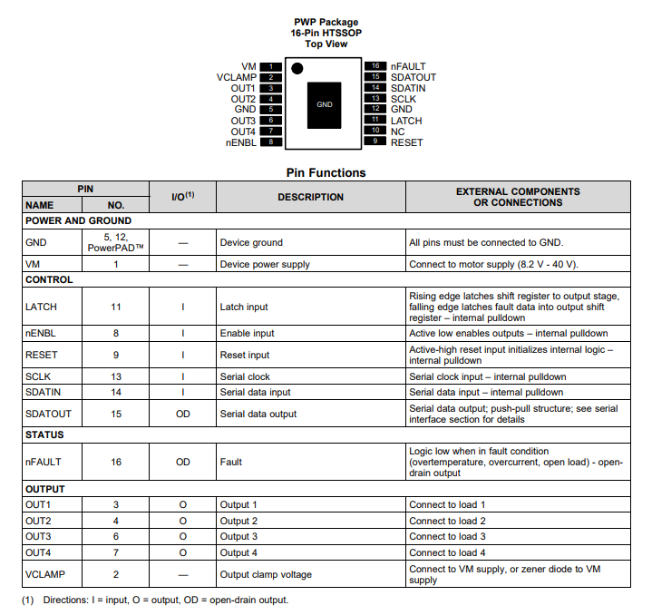

**Appendix 2 – ILI9341 2.8” TFT display**

<https://github.com/loboris/ESP32_TFT_library>

* Preferred TFT screen:
  + 3.5” variant:
    - Kuman 3.5 inch TFT Touch Screen with SD Card Socket Compatible for Arduino Mega2560 Board SC3A-1
    - <https://www.amazon.com/Kuman-Arduino-Screen-Tutorials-Mega2560/dp/B075FP83V5?psc=1>
  + 2.8” variant:
    - UNO R3 2.8 TFT Touch Screen with SD Card Socket for Arduino Board Module
    - <https://www.amazon.com/Touch-Screen-Socket-Arduino-Module/dp/B00UAA2XIC?psc=1>